### **Experience**

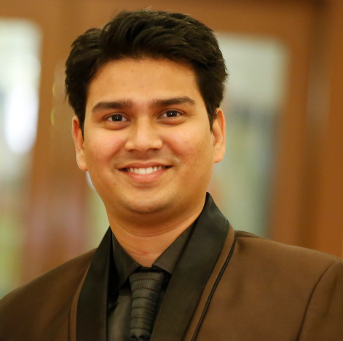

**Uday Kumar LOKHANDE**

Cyber Security Specialist

# **Objective**

***Automate****,* ***Secure****,* ***Audit*** *the Organization! Keep it* ***Complied*** *&* ***Ahead*** *in IT Business Race!*

## **Skills & Abilities**

GRC, Audit, Compliance, Risk Assessment, Policy, Procedure, Standards, Documentation, Ethical Hacking, Process Automation, DevSecOps, Security Architect review, Presentation, Contracts, Agreements.

## **Vitals**

Al Jawhara Hotel, Dubai

**M** +971-588600185

**W** +91-9867849624

**E** [udayom@gmail.com](mailto:udayom@gmail.com)

**VISA** – dnata UAE

**Passport** - M5233400

**Skype** ID – udayom

**LinkedIn/FB** ID – [udayom](http://www.linkedin.com/in/udayom)

[linkedin.com/in/udayom](http://www.linkedin.com/in/udayom)

**Publications** – [IEEE](http://ieeexplore.ieee.org/xpl/articleDetails.jsp?tp=&arnumber=6398169), [IJAIR](http://www.advanceresearchlibrary.com/ijairp19.aspx)

#### Emirates Group, Cyber Security Lead, DUBAI

##### April 2019 – Till DATE (~ **2 Year**)

#### Risk Assessment: Conducting Third party Risk assessment, documenting Policies procedures standards, Audits, compliance, Architecture Reviews and Risk assessment in projects, GDPR and PCI DSS compliance checks.

#### Khidmaty Services, Cyber Security Lead, DUBAI

##### MARCH 2018 – April 2019 (~ **1 Year**)

**Operational Security –** Penetration testing (Kali based) - (VAPT) Manual and Automated – Web Application, Server, Mobile Application. Black box test. IT Operational Tools Administration & Standardization of process for Compliance  
.  
**Governance Security –** Make the **Policy and Procedures** documentation for ISO 27001, Vulnerability closure from respective owners, Conducting Security Awareness sessions, Audit Internally for regulating the compliance of company

#### Finacus Solutions, Security Manager, Mumbai

##### JUNE 2017 to – March 2018 (~ **1 Year**)

Define Policy and Procedure for **ISO 27001** and Compliance readiness for **PCI DSS** both technically & operationally (includes VAPT on multi-environment), **Automation** of process for deployment, Review Evidences, Analyze Logs/ Firewall Rules, build complete Evidence for the Audit of **PCI DSS** including ROC, ASV, ROV. Organization level Compliance for maintaining status Quo.

#### CAPGEMINI INDIA, SOFTWARE Engineer, MUmbai

##### Nov 2014 – June 2017 (~ **3 Years**)

**Governance**: Perform Audits, revamp existing policies and procedures for ISO and **PCI DSS**, comply with standards, present the security reports to clients, Quarterly review of various tools, policies, procedures and processes. Make Audit Trails for Tools, Perform Internal Audits. Consult based on VAPT reports   
.  
**Operational**: Administering DevOps tools such as AppDynamics, MongoDB, ELK Stack, Puppet, Ansible, Nagios, Nginx, Dynatrace, Graphite, Grafana, docker, Zeus, Munin, Jenkins, OSSEC, IPS & perform VAPT on web&/servers

### **Education**

#### [M.tECH – IT, Mumbai University](https://badges.wes.org/Evidence?i=d8dfd6e3-c724-404f-b08c-cdcf0a822eeb&type=ca), Mumbai, India

CGPA 8.5 (College Boys **Topper**), Also holding **PGDM** from Welingkar Institute, Mumbai + **B.TECH.** & **Diploma** in **Cyber Law**, India

### **CERTIFICATIONS**

* [CRISC](https://www.youracclaim.com/badges/3bf0e5e4-a1f3-4ab0-ad1b-04ddcf1b0b56) (ISACA-2020)
* [CISSP](https://www.youracclaim.com/badges/a3ee04d8-3a65-429c-a925-da4cd7867529/public_url) (ISC2-2020)
* [PCI DSS](https://raw.githubusercontent.com/udayom/udayom.github.io/master/cert/pcidss-cert.jpg) Qualified Implementer (QRC-2017)
* [GDPR](https://raw.githubusercontent.com/udayom/udayom.github.io/master/cert/gdpr-practitioner.png), ISO/IEC [31000](https://raw.githubusercontent.com/udayom/udayom.github.io/master/cert/iso31k.png), [270001](https://raw.githubusercontent.com/udayom/udayom.github.io/master/cert/iso27k1-cert.JPG)-LA (TuV SuD 2020, 2017)
* [AWS Certified Solution Architect](https://www.youracclaim.com/badges/236f2920-e022-4ecd-acd6-02d884a5961e/linked_in_profile) – Associate (AWS-2019)
* [C|CISO](https://aspen.eccouncil.org/VerifyBadge?type=certification&a=IpQpK9fbi3TDnn80XmMdm8iIpCG22cXKW2lOSxc8DXc=) (EC-Council 2019)
* [CHFI](https://aspen.eccouncil.org/VerifyBadge?type=certification&a=z9HKV3jBjCb0hl0gco/MszNSWxJmNxshyeI2sw5kWtU=) , [CEH](https://aspen.eccouncil.org/VerifyBadge?type=certification&a=nYMsFOnMM38LHrQrms6ZXOcuVd4L8B1hgmf9vkA9vcg=) (EC-Council 2020)